Thomas Jubb

MMA Companion
Computer Science NEA

Contents
Developmental Testing Error! Bookmark not defined.
Testing Error! Bookmark not defined.

Stage | Problem/Result | Evidence | Action | Evidence of action
Proto | I did not set my parameters in the code correctly (2.1 and 2.2) I put the string “None” instead of Nonee | 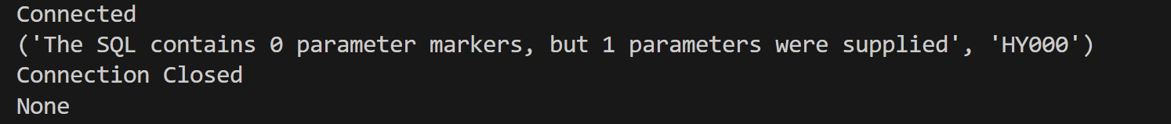 | Set params to equal None instead of “None”
Proto | Table is outputted as an array (2.1 and 2.2) |  | No action needed
Proto | Table with specific required fields is outputted (2.1 and 2.2) |  | No action needed
Proto | Leaderboard table didn’t load because I had the login button set to navigate not load the table (2.3 and 2.4) | 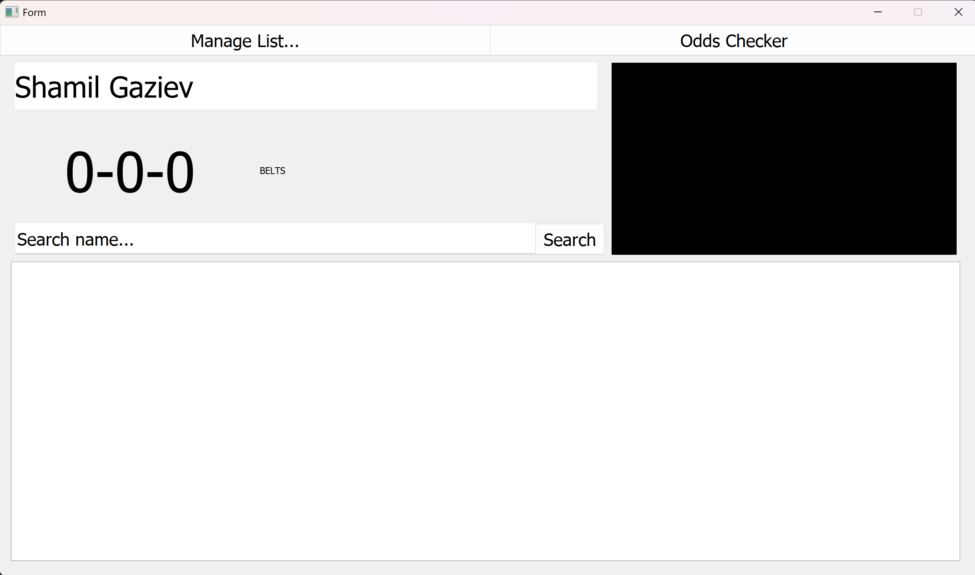  Leaderboard did not load | Set login subroutine to load leaderboard instead of navigate (load leaderboard will navigate) | 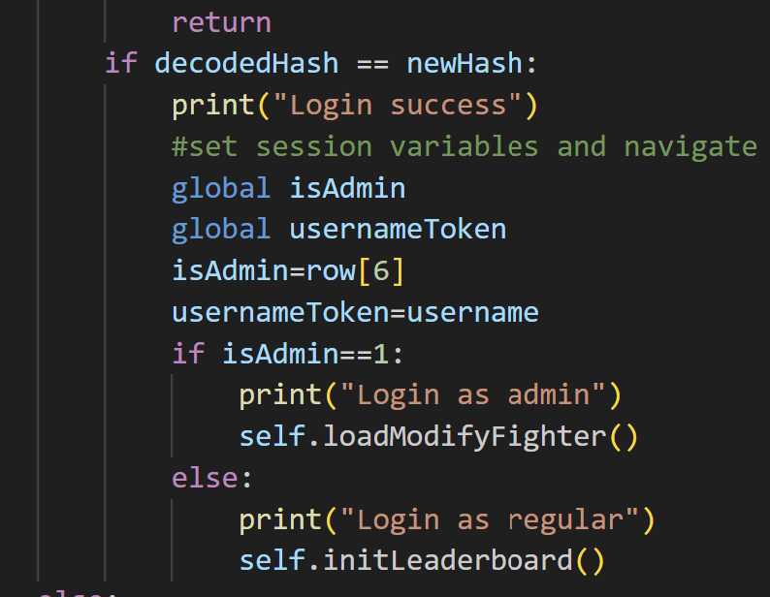
Proto | Table cleared and set to a model (2.3 and 2.4) | 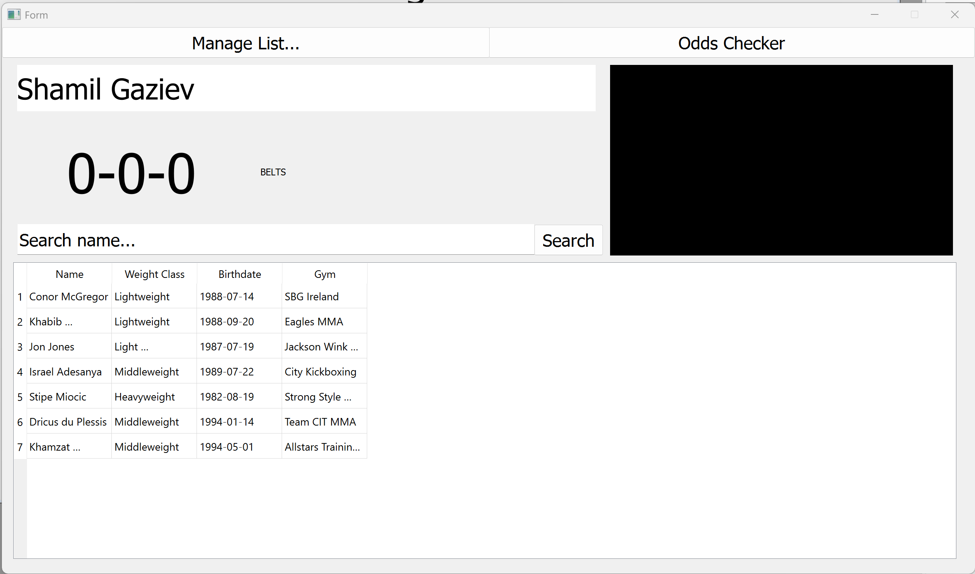 | No action needed in terms of the actual subproblem
Proto | Table isn’t sized properly to the tableView |  | Changed the header and table properties to make it look nicer | 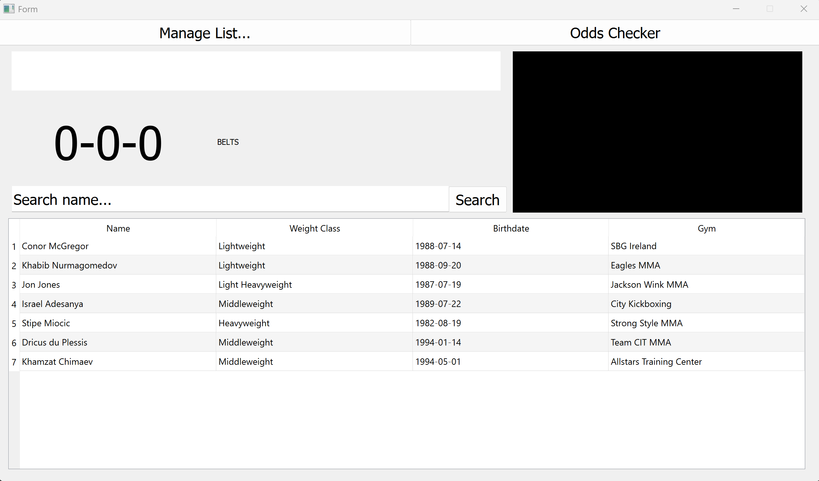
Proto | I kept self when loading the default image |  | Took self out
Proto | I referred to the element when loading the image through itself | 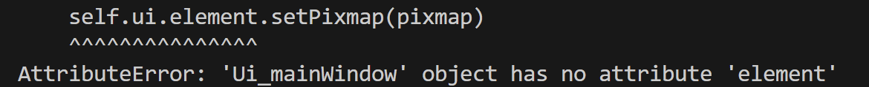  (I meant self.ui.element but it would come out as self.ui.self.ui.element) | Did element instead of self.ui.element | 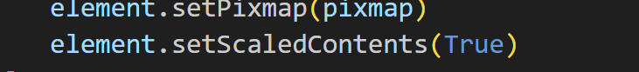
Proto | Nothing happens when I click the table cells because I messed up the handler | 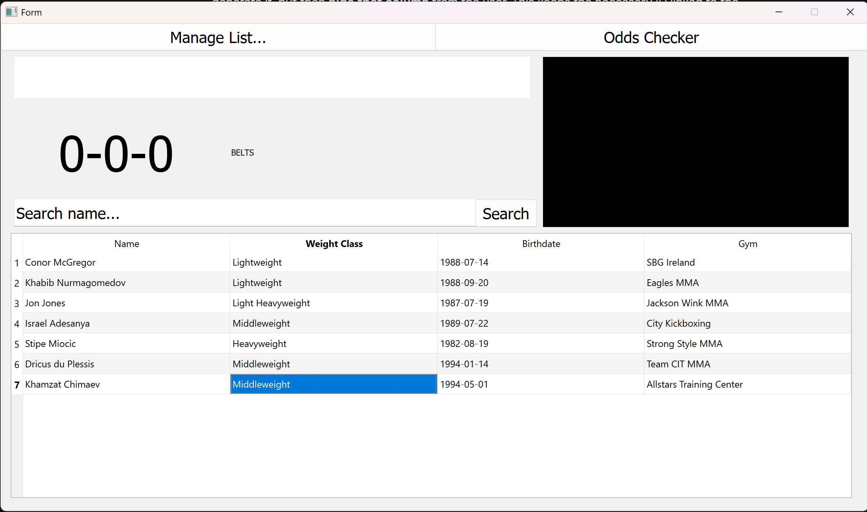 | Corrected handler
Proto | Images look stupidly scaled because the pixmap properties don’t preserve the aspect ratio | 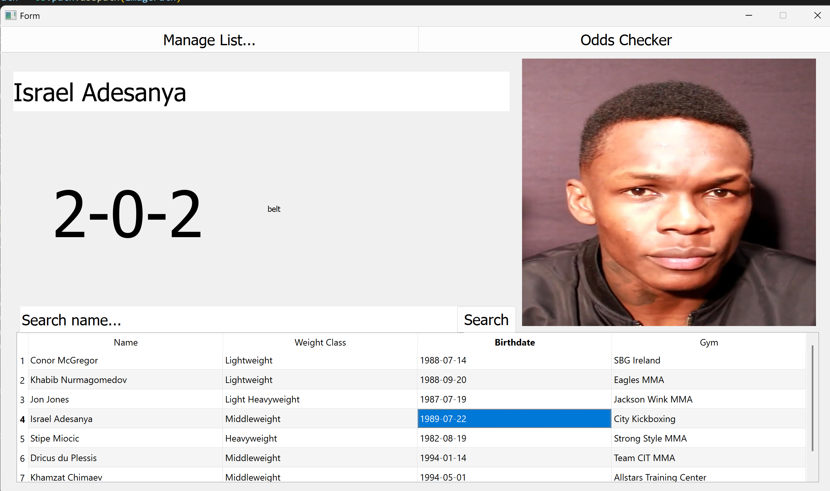 | Set new pixmap properties when loading images to preserve the aspect ratio | 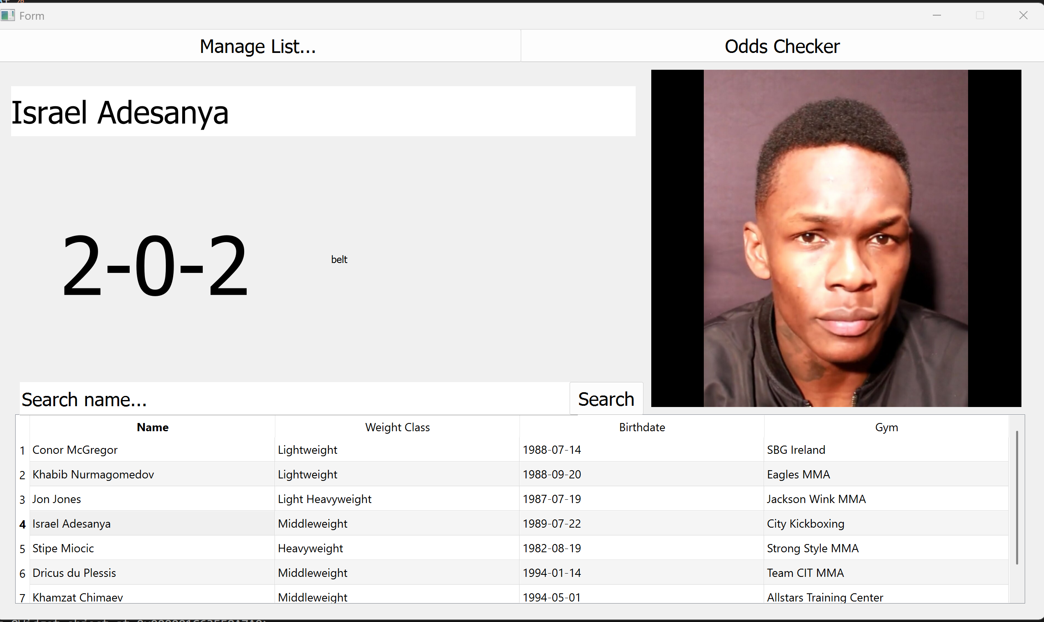
Proto | PyQT cannot get the text out of the search bar because it’s the wrong element | 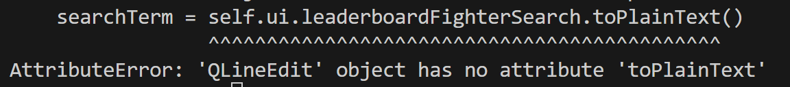 | Change leaderboardfightersearch to a TextEdit element
Proto | Result of search also models the id inadvertently | 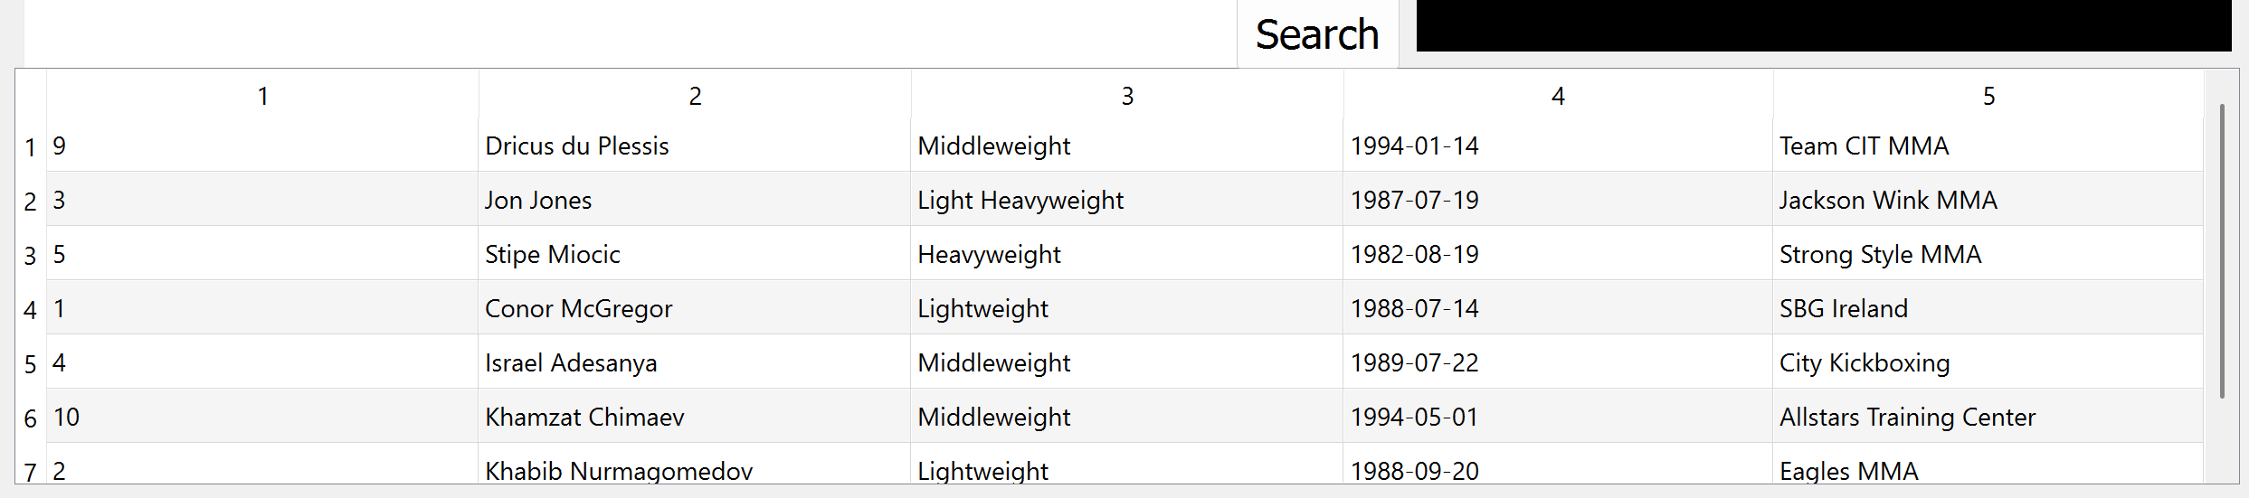 | Add header declarations into the modelling of the search table | 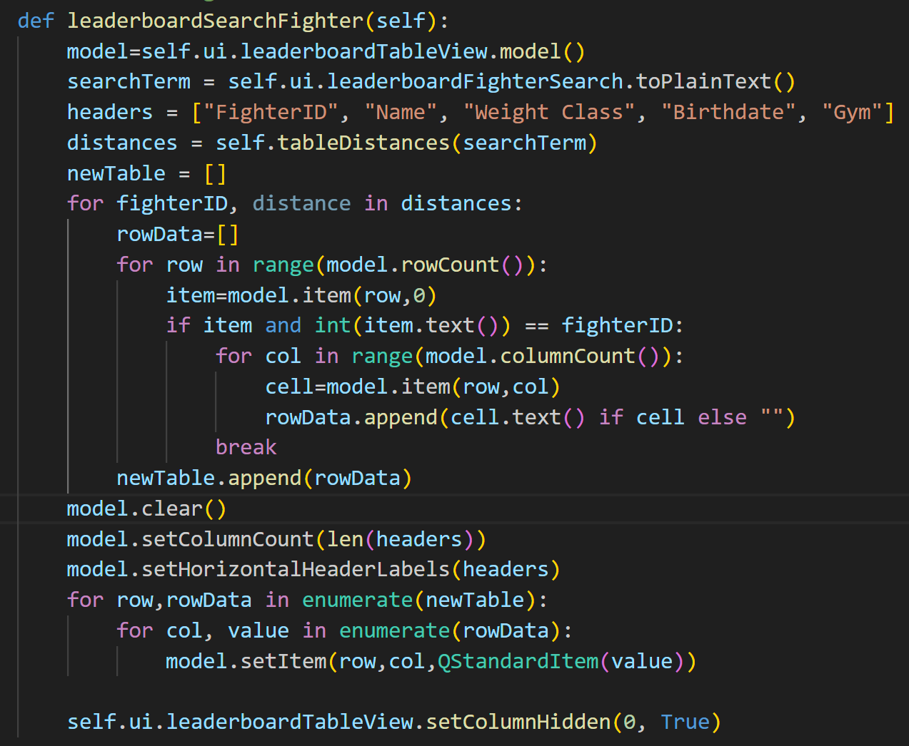
Proto | Double click to profile mechanic stutters because of image loading times | 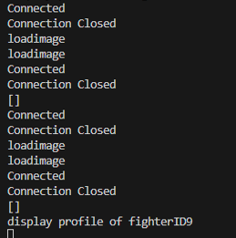  Is hard to show without showing it in real time, but you can see how it is tedious to load and double-click at the same time | I need to thread the request so everything doesn’t stop to load the image
Proto | Implementing tooltip system onto edit fighter fights list so admins can see the opponents of each fight | 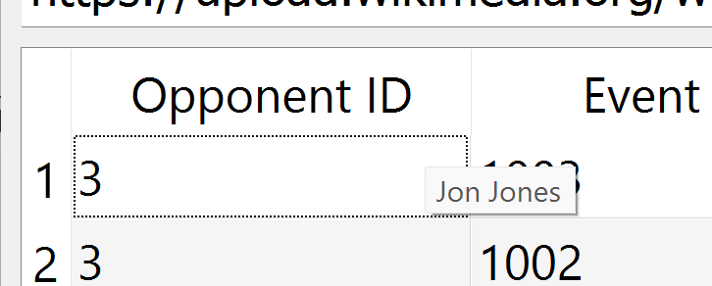 | No further action needed
Proto | When the fighter profile is switched it doesn’t clear the image | 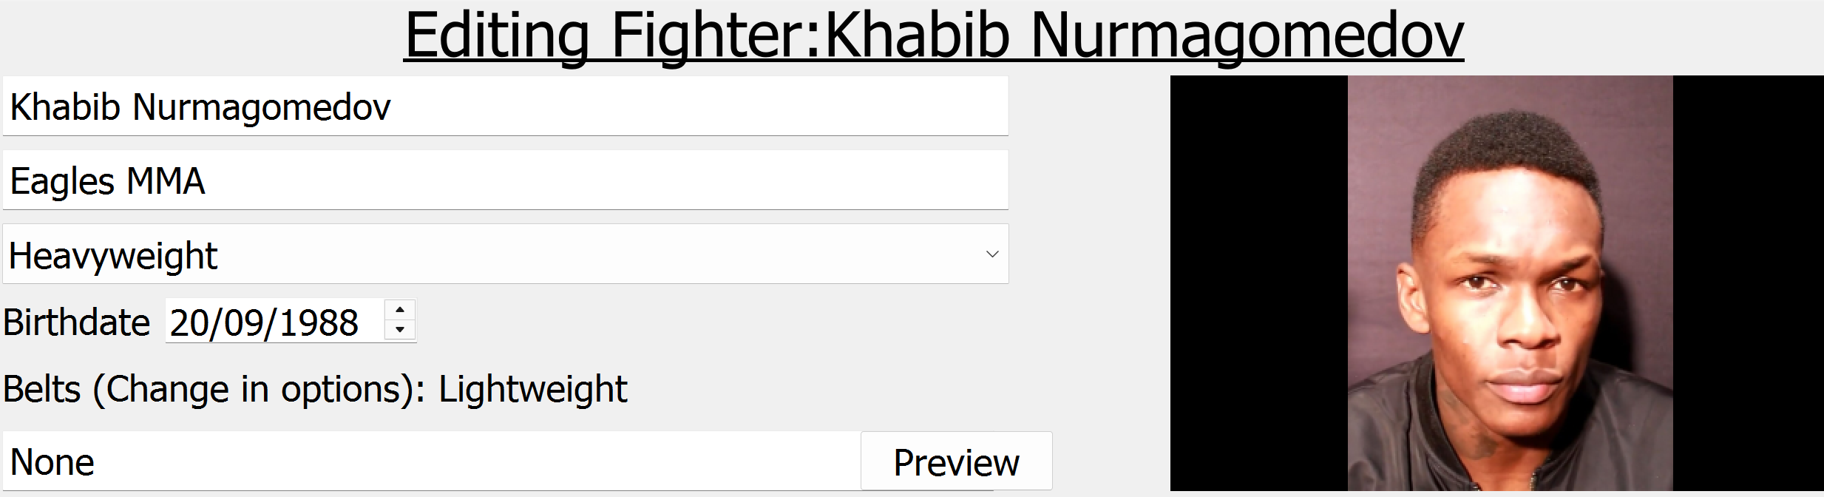 | Clear the element at the beginning of the load image subroutine | 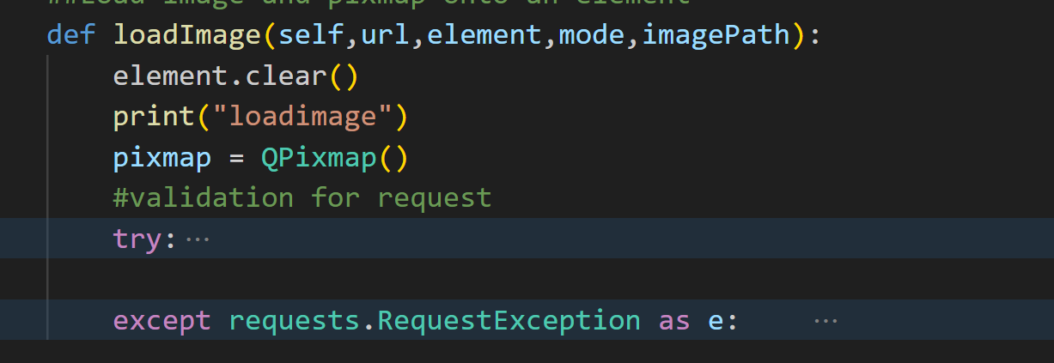
Proto | Implement table editing system | 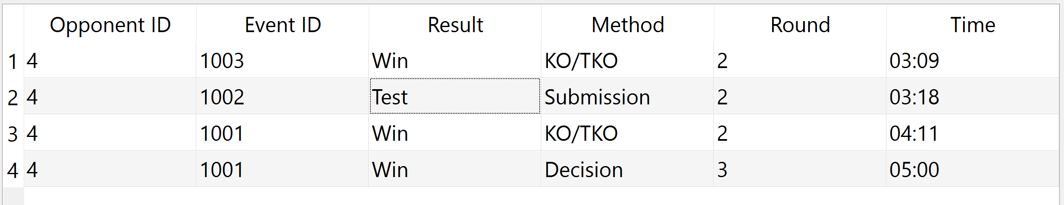  When I clicked submit and came back to the table it hadn’t updated
Proto | Double click passes to subroutine with fighter ID |  | No further action needed
Proto | Pie chart looks ugly because of the jargon of the unused things | 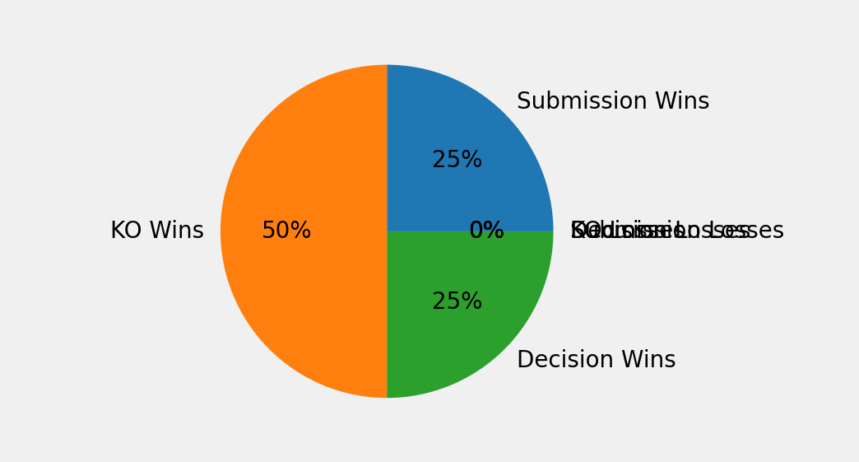 | Omit the parts of the pie chart that aren’t used | 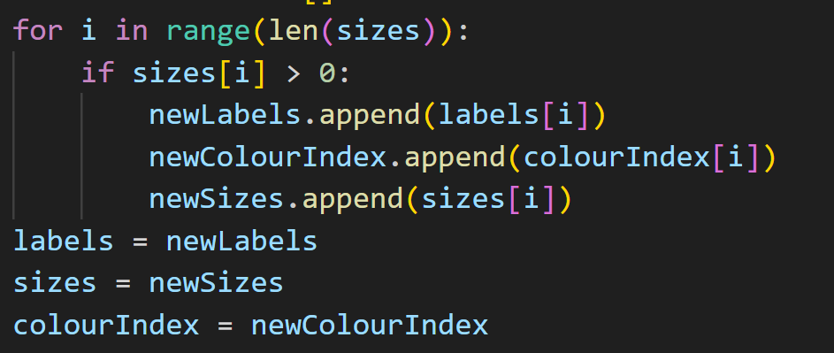  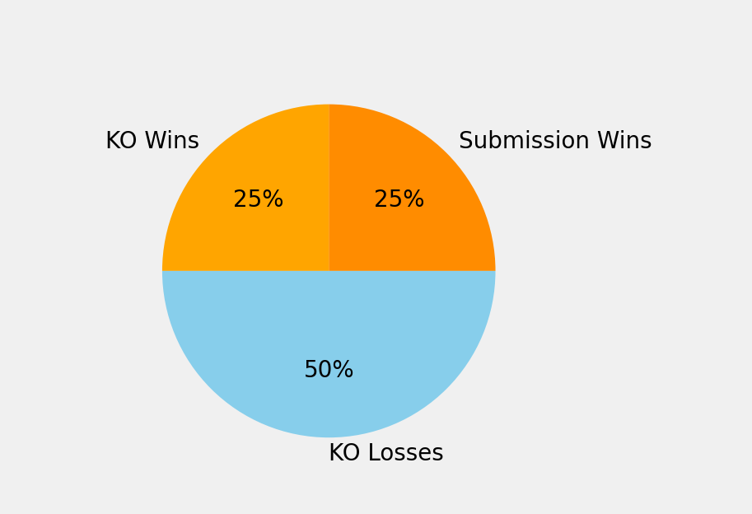
Proto | I messed up the parameters in this query | 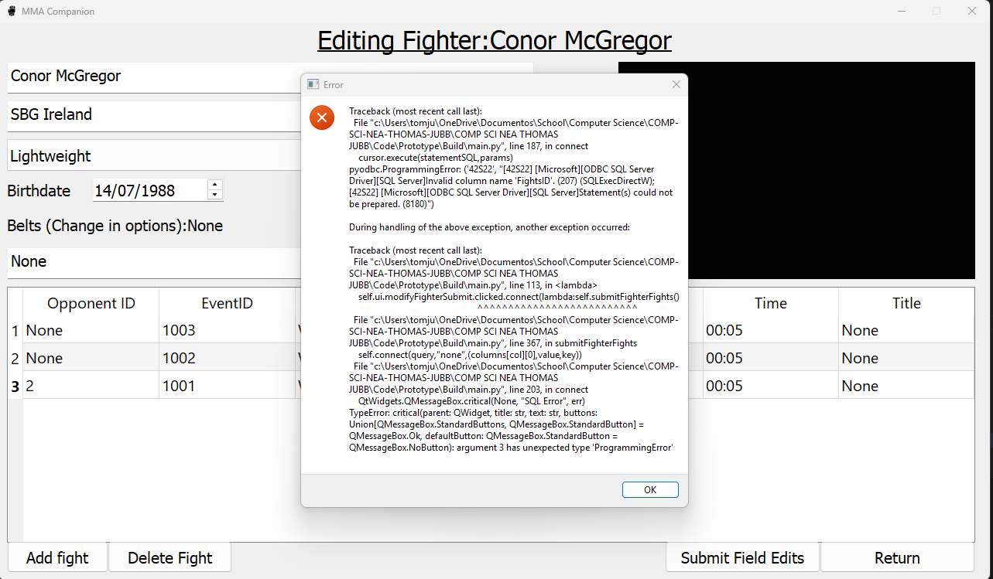  (Image says it expected 1 parameter but two was supplied | Take out parameter | Runs fine now
Proto | I called the datetime function incorrectly | 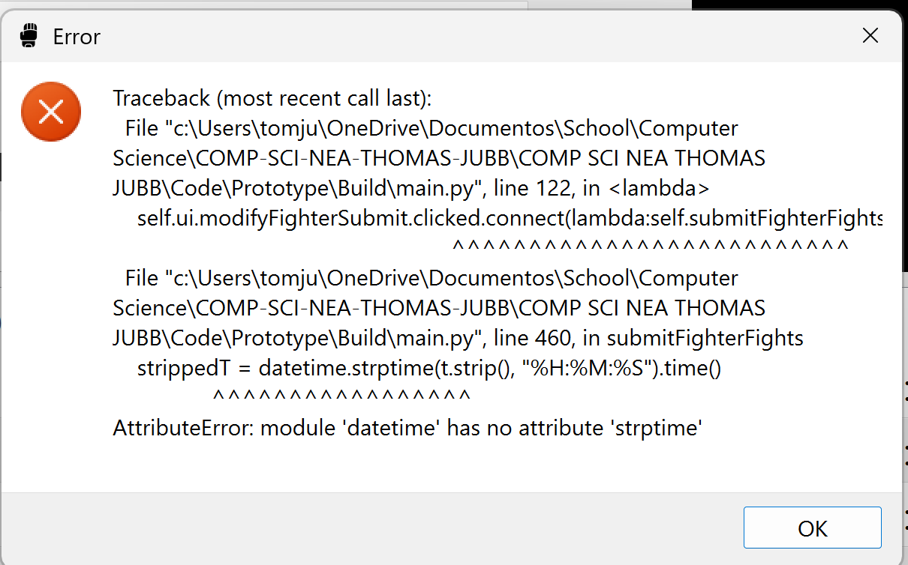 | Change the calling of datetime to datetime.datetime | (this is just how it works for some reason)
Proto | I dealt with belt result list indexing wrong | 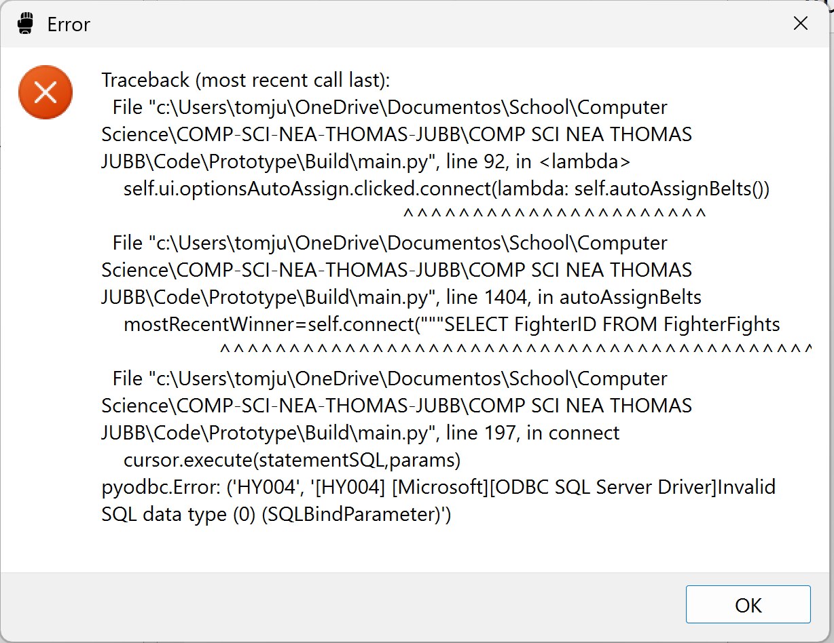 | I accidentally set the parameter of a list wrong as I interpreted it as a one-dimensional list instead of a two dimensional | 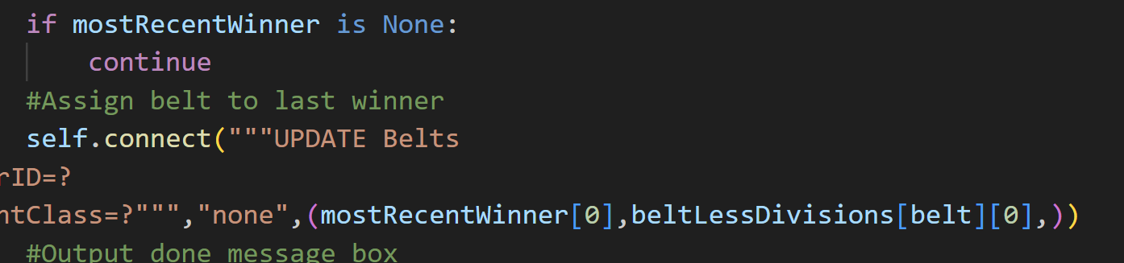
Proto | I formatted a string wrong by using , and then + | 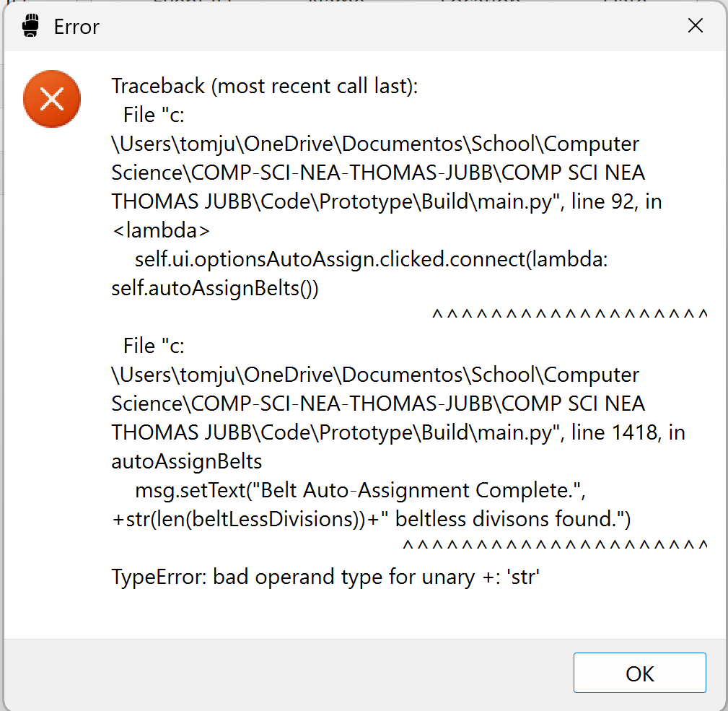 | I took the , out
Proto | I put the brackets on this part the wrong way around | 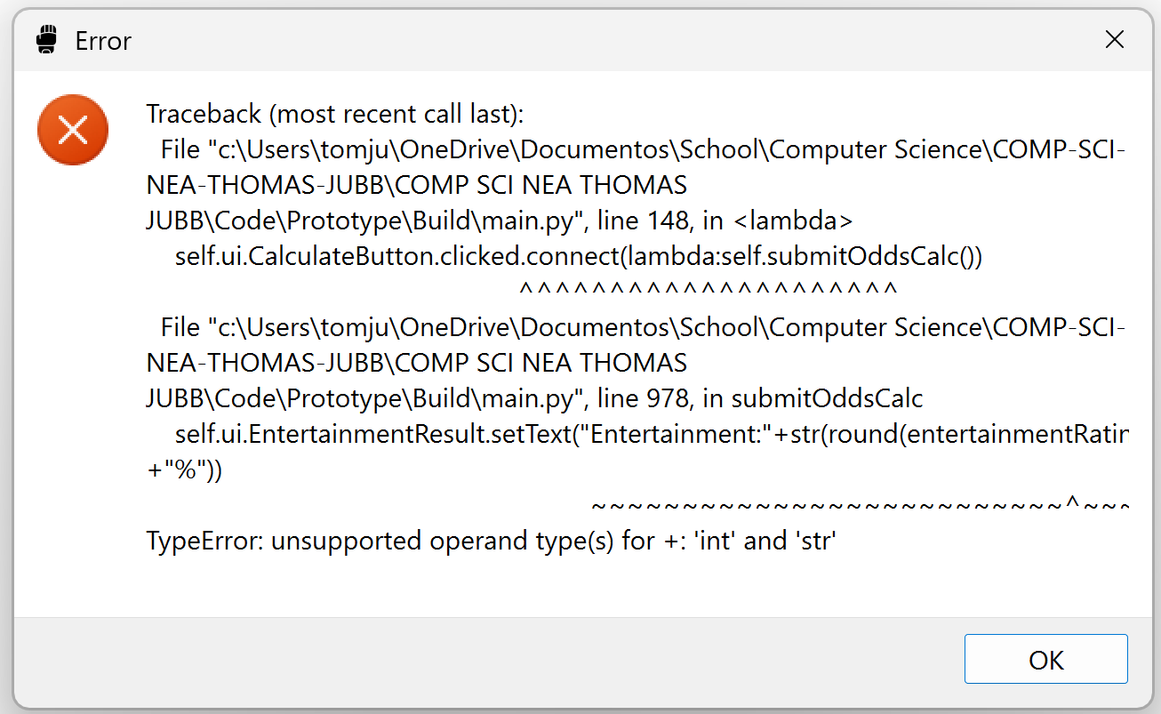 | I put the + outside of the round so the program doesn’t think the percentage is a number
Proto | I set my starting volatility to 350 which causes the elo ratings of fighters to spike to absurd amounts |  | I am going to change the starting volatility to 0.06 | 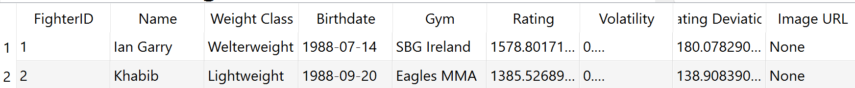  Elos are now normal numbers now  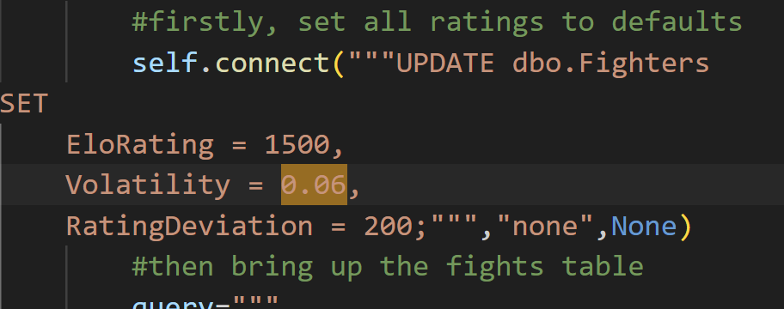
Post-Proto | I did not specify the favouriteFighter column in the insert query | 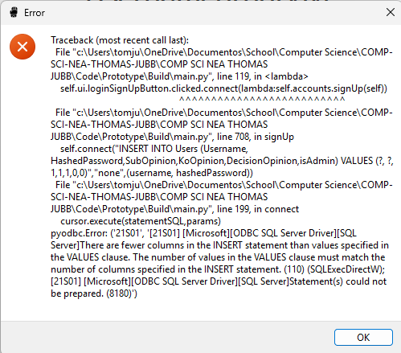 | Specify favouriteFighter | 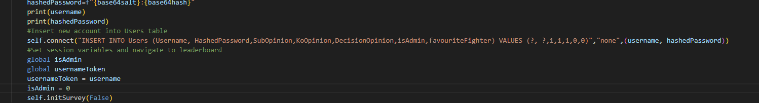  Works fine now
Post-  Proto | I forgot to set height to a float which means that a type error occurs. | 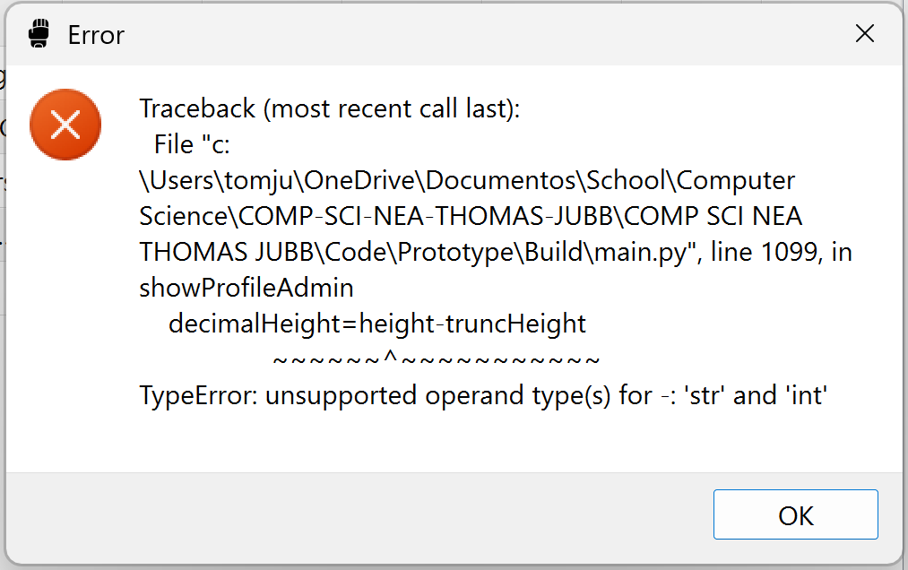 | Declare height as a float | 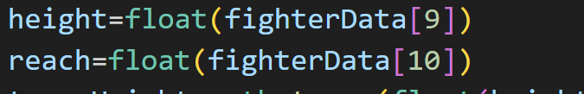
Post-Proto | I used the wrong function to set a QLabel’s text. | 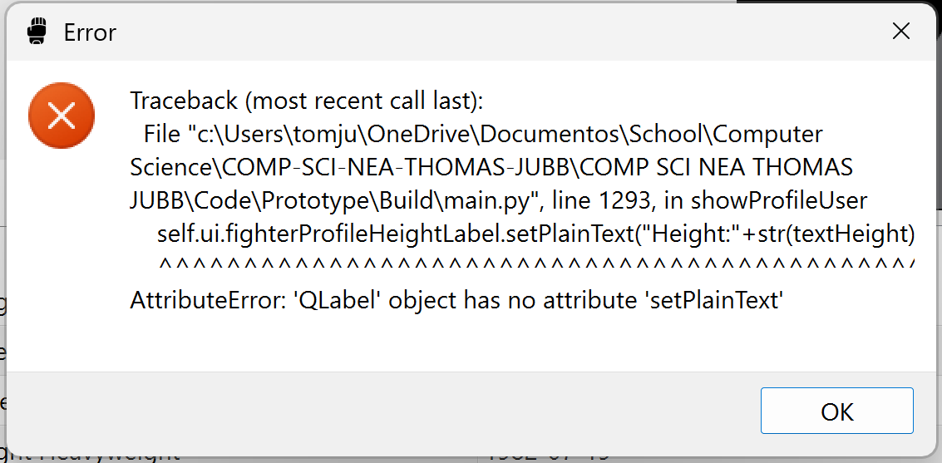 | Do a setText instead of setPlainText as that is what QLabel uses.

